**Top 25 API Testing Interview Questions – Rahul Shetty**

**What all challenges are included under API testing?**API Documentation  
Access to DB  
Authorization overhead

1. **What is the difference between PUT and POST methods?**

POST request - creating a new object on the server

PUT request, Update the object in server with new value

1. **What are commonly used HTTP Methods?**

**GET:** It enables you to retrieve data from a server  
**POST:** It enables you to add data to an existing file or resource in a server  
**PUT:** It lets you replace an existing file or resource in a server  
**DELETE:** It lets you delete data from a server

1. **List out few Authentication Techniques used in API’s?**

Session/Cookie Based Authentication  
Basic Authentication  
Digest Authentication  
OAuth

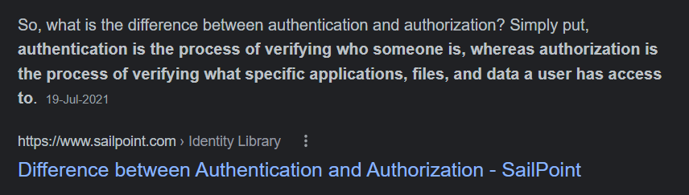

1. **Why API testing is determined as the most suitable form for Automation testing?**

Lightweight

Reliable, no sync issues

1. **What is Rest API?**

REST stands for Representational State Transfer. It is a set of functions helping developers in performing requests and receive responses. Interaction is made through HTTP Protocol in REST API.

**SOAP Vs REST**

* SOAP stands for **S**imple **O**bject **A**ccess **P**rotocol and REST stands for **RE**presentational **S**tate **T**ransfer.
* Since SOAP is a protocol, it follows a strict standard to allow communication between the client and the server whereas REST is an architectural style that doesn’t follow any strict standard but follows six constraints defined by Roy Fielding in 2000. Those constraints are – Uniform Interface, Client-Server, Stateless, Cacheable, Layered System, Code on Demand.
* SOAP uses only XML for exchanging information in its message format whereas REST is not restricted to XML and its the choice of implementer which Media-Type to use like XML, JSON, Plain-text. Moreover, REST can use SOAP protocol but SOAP cannot use REST.

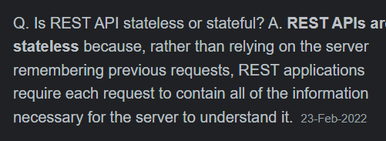

### What exactly needs to verify in API testing?

In API testing, we send a request to API with the known data and then analysis the response.

1. We will verify the accuracy of the data.
2. Will see the HTTP status code.
3. We will see the response time.
4. Error codes in case API returns any errors.
5. Authorization would be check.
6. Non-Functional testing such as performance testing, security testing.
7. **What are Path Parameters and Query Parameters for below API request URL**http:/rahulshettyacademy.com/orders/112234?location=IND

Path Parameter = 112234, after the /

Query Parameter = location=IND, after the ?

### What are the core components of an HTTP request?

1. HTTP Request methods like:, PUT, POST, DELETE.
2. Base Uniform Resource Identifier (URI)
3. Resources and Parameters
4. Request Header, which carries metadata (as key-value pairs) for the HTTP Request message.
5. Request Body, which indicates the message content or resource representation.
6. **What could be the HTTP Method for below API Scenario? Answer if it is GET or POST**

***Scenario***: An API which has Endpoint, Parameters, Headers, cookies and Payload

Ans : POST

### What are the differences between API testing and UI testing?

UI (User Interface) testing means the testing of the graphical user interface. The focus of UI testing is on the look and feel of the application. In user interface testing the main focus is on how users can interact with app elements such as images, fonts, layout etc. are checked.

API testing allows the communication between two software systems. API testing works on backend also known as backend testing.

### What protocol is used by the RESTFUL Web Services?

RESTFUL Web Services uses the HTTP protocol. They use the HTTP protocol as a medium of communication between the client and the server.

1. **What are Soap WebServices?**

SOAP stands for Simple Object Access Protocol. It is an XML based messaging protocol. It helps in exchanging information among computers.

1. **How do we Represent A Resource In REST?**

Using HTTP Methods.

1. **Can you use GET request instead of PUT to create a resource?**

No, GET request only allows read only rights. It enables you to retrieve data from a server but not create a resource. PUT or POST methods should be used to create a resource.

POST should be used when the client sends the page to the server and then the server lets the client know where it put it. PUT should be used when the client specifies the location of the page

1. **Can you use POST request instead of PUT to create a resource?**

Yes We can. Because POST is super set of all other HTTP methods except GET

### What Do You Understand by Payload In Restful Web Service?

**Ans.** Payload/Body is the secured input data which is sent to API to process the request. Payload is generally represented in Json fomat in Rest API’s

1. **How do we differentiate Path and Query Parameters in API Request Endpoint?**

http:/rahulshettyacademy.com/orders/112234?location=IND

Path Parameter = 112234, after the /

Query Parameter = location=IND, after the ?

1. **What is Rest Assured?**  
   It is Java library which can automate Rest API’s
2. **How would we define API details in Rest Assured Automation?**

We shall define all the request details and Send it to sever in GIVEN, WHEN , THEN methods

1. **What is Json Serialization & Deserialization in Rest Assured?**

**Serialization** in Rest Assured context is a process of converting a Java object into Request body (Payload)

Rest Assured also Supports **deserialization** by converting Response body back to Java object

1. **List out few common Json Parsing Techniques used in Rest Assured Automation?**

Json Path  
Deserialization of Json using POJO Classes

1. **How would you send attachments to API using Rest Assured Test?**  
     
   Using MultiPart method
2. **Different Status Codes and their descriptions**

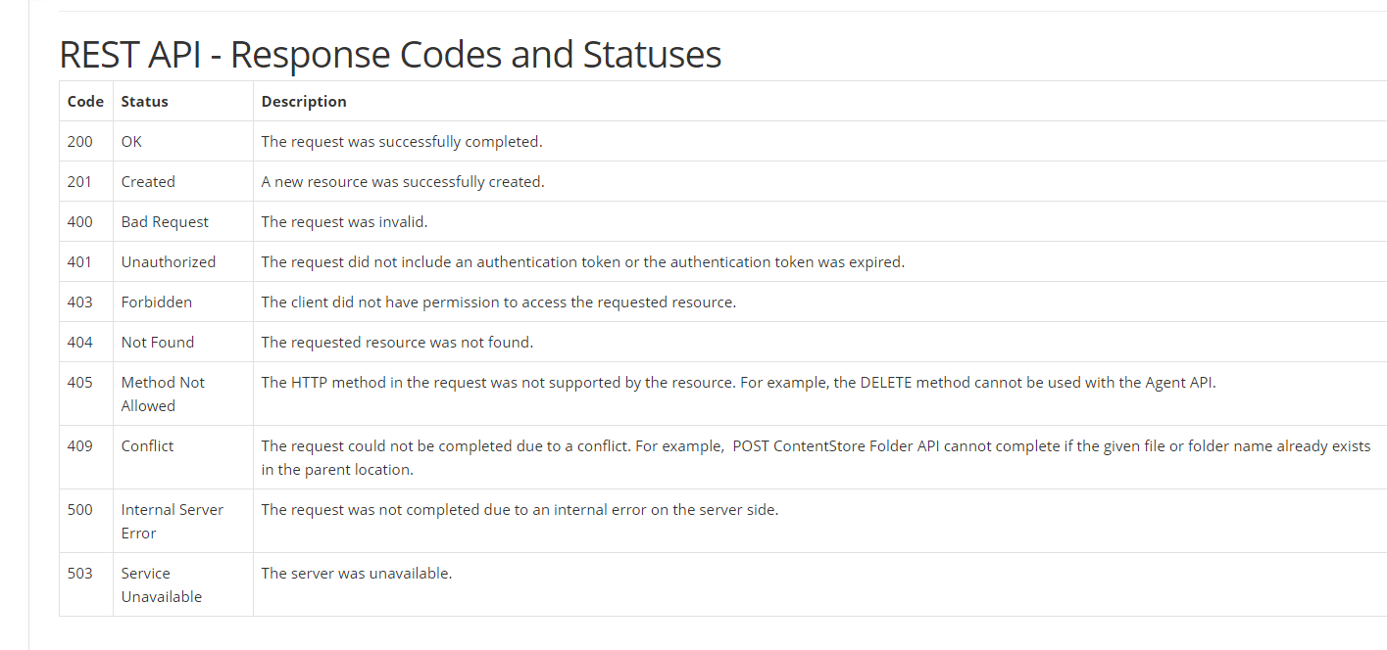

1. Get the Json Path of “site” from below JSON

{

"dashboard": {

"purchaseAmount": 910,

"website": "rahulshettyacademy.com"

},

"courses": [

{

"title": "Selenium Python",

"price": 50,

"copies": 6,

"details":

{

"site" : "http://rahulshettyacademy.com"

}

},

{

"title": "Cypress",

"price": 40,

"copies": 4

},

{

"title": "RPA",

"price": 45,

"copies": 10

}

]

}